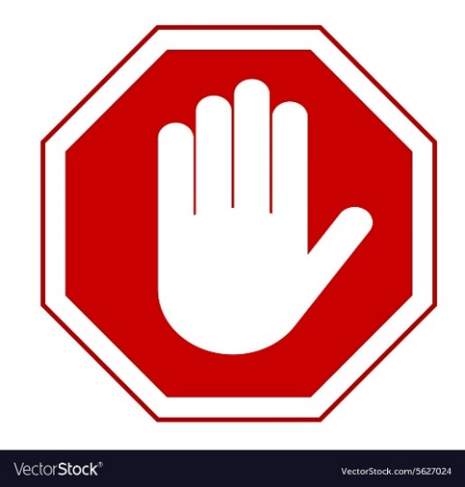
STOP!
To All Staff and Visitors.
Please read the notice below before entering.

If you are in Groups 1 and 2 we would respectfully ask that you
do not enter our facility. We will be happy to help if you contact
us by telephone.
Even if you do not have symptoms please do not enter this building.
To protect yourself and others go home and search ‘nhs coronavirus’
for advice and access the 111 online coronavirus service or call NHS 111

The health and wellbeing of all clients, staff and members of the public is our highest priority.

Novel Coronavirus (COVID-19)
Group 1

- You or someone in your household has had contact with a confirmed case of coronavirus in the previous 14 days.
- You or someone in your household has travelled in the previous 14 days from:
  - Iran
  - Specific lockdown areas in Italy*
  - Special care zones in South Korea**
  - Hubei Province including Wuhan, China
Group 2

- You or someone in your household has travelled to one of the countries listed below in the last 14 days and have symptoms including a cough, fever or shortness of breath, even if mild:
  - Italy*
  - Vietnam
  - Cambodia
  - Laos
  - Myanmar
  - Mainland China
  - Thailand
  - Japan
  - Republic of Korea
  - Hong Kong
  - Taiwan
  - Singapore
  - Malaysia
  - Macau
Group 3

- You or someone in your household have travelled in the previous 14 days from a country listed in group 2 and do not have symptoms

Thank you for your cooperation.

*Group 1 areas: Lombardy (inc Mila, Bergamo, Como and Provinces), Emilia Romagna (inc Modena, Parma, Piacenza, Reggio Emilia, Rimini), Marche (inc Pesaro e Urbino), Piemonte (inc Alessandria, Asti, Novara, Verbano-Cusio-Ossola and Vercelli) and Veneto (inc Padova, Treviso and Venezia)
** Daegu and Cheongdo

